The Impact of the Crucifixion on the Disciples of Jesus:
Jesus death and resurrection obviously had a massive impact on his disciples. Here was a man whom they had given everything up for. They had left their jobs, their lives, in some cases their families to follow this man and his teachings. They were devastated when he was arrested, tried and murdered as a criminal. They were confused, their lives were in ruins, they didn’t know where to turn.
However, with the resurrection on Easter Sunday they slowly began to realise that Jesus was more than they ever imagined. They realised that through Jesus Christ God was revealing himself to humanity. This is known as the Incarnation.
Jesus death and resurrection had a big impact on the disciples in three ways
They now had a sense of mission | At Pentecost the Holy Spirit came down on the apostles and told them ‘Go and make disciples of all nations…and remember, I am with you always’.  From this moment on they knew they had a mission to carry on the work begun in Jesus and they he would be with them always.
They now had awareness that they were a new community. | The disciples of Jesus saw themselves as a new community. The Acts of the Apoltles tells us that ‘they spent much time together in the temple, they broke bread together and day by day added to their number’.  They knew that if they were to be successful in fulfilling the mission begun by Jesus they would have to do it together as a community.
They finally saw Jesus as the Mediator of Salvation (The saviour of the human race) | 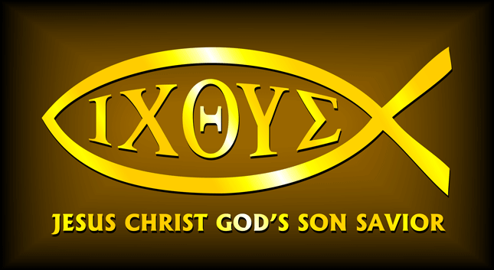  The disciples understood that Jesus gave up his life so that the whole human race would be saved from sin.  The Early Christians used the symbol of the fish as a symbol of Christianity. The 5 Greek letters that spell fish are an acronym for: Jesus Christ, Son of God, and Saviour.  The early Christians understood themselves as being slaves to sin. A slave could be redeemed if someone bought their freedomThey understood Jesus as having freed humanity and paying with his life and as such was the mediator of salvation.

