Primal Religions:

All religions are rooted in the ancient, primal traditions of our ancestors from about 50,000 years ago.

Our ancestors were primitive, agricultural people who were very closely linked with nature. They were all too well aware of the power of nature with storms, floods, disease and famine and they respected and worshipped nature as a result.

Thousands of individual and distinct religions existed and were practiced in the ancient world. These include:
o The Sumerians in Mesopotamia who built ziggurat temples (pyramid shaped towers)
o The Maya tradition of Central America (Remember the Mayan calendar that said the world would end in 2012)
o Thousands of ancient religions stem from Africa
o The Maori people of New Zealand who placed great emphasis on the land as being sacred.

All of these ancient religions are grouped together for three reasons:
1.They are all very similar in how they look at the world as being sacred. They saw no distinction between secular and sacred. To them everything was considered sacred.
2.They passed on all of their traditions orally – very little was ever actually written down.
3.They expressed their relationship with their God(s) through myths and legends. These myths showed their desire to have a human-divine relationship with their God(s).

As we studied in section A of our course, we know that our ancestors took great care with the burial of the dead, creation of religious art, offering up sacrifices, etc. Such activities show that our ancestors had a strong belief in spirits and the divine. They used signs and symbols to express the complex feelings they had for their Gods.

Religion today, as it did all those thousands of years ago tries to provide answers for life’s greatest questions, it provided avenues for exploration of life, it gave encouragement, inspiration, comfort and provided a means of being fully human.

There are 4 distinct terms linked with primal religion that we need to explore and understand.
These are:

MANA (Sacred Object)
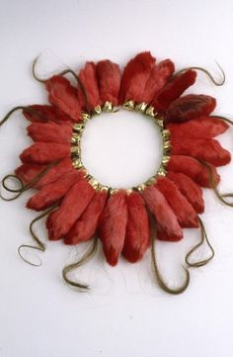
TABU (Rules to Protect the Sacred Object)
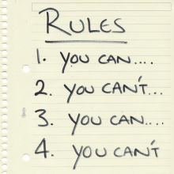
TOTEM (A Symbol)
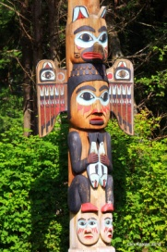
SHAMAN (Holy Man)

