Holy Week - Day 1: Palm Sunday's Triumphal Entry
On the Sunday before his death, Jesus began his trip to Jerusalem, knowing that soon he would lay down his life for the sins of the world. Nearing the village of Bethphage, he sent two of his disciples ahead to look for a donkey with its unbroken colt. Jesus instructed the disciples to untie the animals and bring them to him.

Then Jesus sat on the young donkey and slowly, humbly, made his triumphal entry into Jerusalem, fulfilling the ancient prophecy in Zechariah 9:9. The crowds welcomed him by waving palm branches in the air and shouting "Hosanna to the Son of David! Blessed is he who comes in the name of the Lord! Hosanna in the highest!"

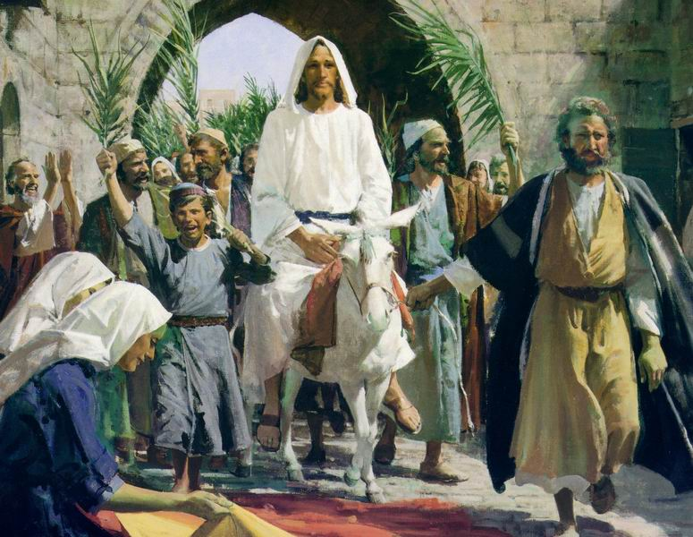
On Palm Sunday, Jesus and his disciples spent the night in Bethany, a town about two miles east of Jerusalem. In all likelihood, Jesus stayed in the home of Mary, Martha, and Lazarus, whom Jesus had raised from the dead.

Holy Week Day 2 – Jesus clears the temple
Today, we continue tracing the footsteps of Jesus, as Monday morning he returned with his disciples to Jerusalem. Along the way, Jesus cursed a fig tree because it had failed to bear fruit. Some scholars believe this cursing of the fig tree represented God's judgment on the spiritually dead religious leaders of Israel.

Others believe the symbolism extended to all believers, demonstrating that genuine, living faith is more than just outward religiosity. True faith must bear spiritual fruit in a person's life.

When Jesus arrived at the Temple he found the courts full of corrupt money changers. He began overturning their tables and clearing the Temple, saying, "The Scriptures declare, 'My Temple will be a house of prayer,' but you have turned it into a den of thieves." (Luke 19:46)
On Monday evening Jesus stayed in Bethany again, probably in the home of his friends, Mary, Martha, and Lazarus.
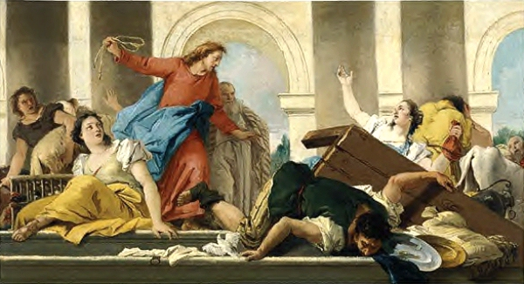
Holy Week Day 3 – Tuesday in Jerusalem, Mount of Olives

Today our journey with Jesus through Holy Week takes us back to the Temple in Jerusalem and then to the Mount of Olives.
On Tuesday morning, Jesus and his disciples returned to Jerusalem. They passed the withered fig tree on their way, and Jesus taught them about faith.

At the Temple, the religious leaders aggressively challenged Jesus' authority, attempting to ambush him and create an opportunity for his arrest. But Jesus evaded their traps and pronounced harsh judgment on them: "Blind guides! ... For you are like whitewashed tombs—beautiful on the outside but filled on the inside with dead people's bones and all sorts of impurity. Outwardly you look like righteous people, but inwardly your hearts are filled with hypocrisy and lawlessness...Snakes! Sons of vipers! How will you escape the judgment of hell?" (Matthew 23:24-33)

Tuesday afternoon Jesus left the city and went with his disciples to the Mount of Olives, which overlooks Jerusalem due east of the Temple. Here Jesus gave the Olivet Discourse, an elaborate prophecy about the destruction of Jerusalem and the end of the age. He taught in parables using symbolic language about end times events, including his Second Coming and the final judgment.
Scripture indicates that Tuesday was the day Judas Iscariot negotiated with the Sanhedrin to betray Jesus (Matthew 26:14-16).
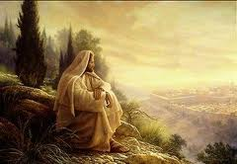
After a tiring day of confrontation and warnings about the future, once again, Jesus and the disciples stayed the night in Bethany.

Holy Week Day 4 – Silent Wednesday
The Bible doesn't say what the Lord did on Wednesday of Passion Week. Scholars speculate that after two exhausting days in Jerusalem, Jesus and his disciples spent this day resting in Bethany in anticipation of the Passover.

Bethany was about two miles east of Jerusalem. Here Lazarus and his two sisters, Mary and Martha lived. They were close friends of Jesus, and probably hosted him and the disciples during these final days in Jerusalem.

Just a short time previously, Jesus had revealed to the disciples, and the world, that he had power over death by raising Lazarus from the grave. After seeing this incredible miracle, many people in Bethany believed that Jesus was the Son of God and put their faith in him. Also in Bethany just a few nights earlier, Lazarus' sister Mary had lovingly anointed the feet of Jesus with expensive perfume.

While we can only speculate, it's fascinating to consider how our Lord Jesus spent this final quiet day with his dearest friends and followers.
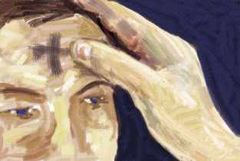
Holy Week Day 5 – Holy Thursday, the Passover, The last Supper.
Our tour through Holy Week takes a somber turn on Thursday.
From Bethany Jesus sent Peter and John ahead to the Upper Room in Jerusalem to make the preparations for the Passover Feast. That evening after sunset, Jesus washed the feet of his disciples as they prepared to share in the Passover. By performing this humble act of service, Jesus demonstrated by example how they were to love one another. Today, many churches practice foot-washing ceremonies as a part of their Maundy Thursday services.

Then Jesus shared the feast of Passover with his disciples saying, "I have been very eager to eat this Passover meal with you before my suffering begins. For I tell you now that I won't eat this meal again until its meaning is fulfilled in the Kingdom of God." (Luke 22:15-16, NLT)

As the Lamb of God, Jesus was about to fulfill the meaning of the Passover by giving his body to be broken and his blood to be shed in sacrifice, freeing us from sin and death. During this Last Supper, Jesus established the Lord's Supper, or Communion, instructing his followers to continually remember his sacrifice by sharing in the elements of bread and wine:
"And he took bread, and when he had given thanks, he broke it and gave it to them, saying, 'This is my body, which is given for you. Do this in remembrance of me.' And likewise the cup after they had eaten, saying, 'This cup that is poured out for you is the new covenant in my blood.' " (Luke 22:19-20, ESV)

Later Jesus and the disciples left the Upper Room and went to the Garden of Gethsemane, where Jesus prayed in agony to God the Father. Luke's Gospel says "his sweat became like great drops of blood falling down to the ground." (Luke 22:44, ESV)

Late that evening in Gethsemane, Jesus was betrayed with a kiss by Judas Iscariot and arrested by the Sanhedrin. He was taken to the home of Caiaphas, the High Priest, where the whole council had gathered to begin making their case against Jesus.
Meanwhile, in the early morning hours as Jesus' trial was getting underway, Peter denied knowing his Master three times before the rooster crowed.
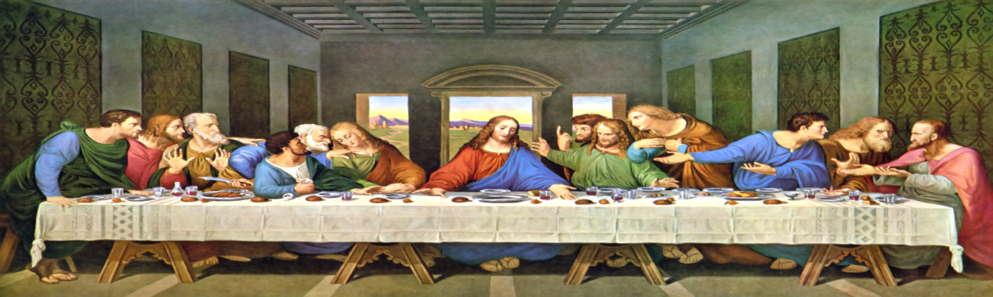
Holy Week Day 5- Good Friday’s trial, crucifixion, burial and death.
Today we'll trace Jesus' steps on Good Friday, the most difficult day of Passion Week. Christ's journey turned treacherous and acutely painful in these final hours leading to his death.

According to Scripture, Judas Iscariot, the disciple who had betrayed Jesus, was overcome with remorse and hanged himself early Friday morning.

Meanwhile, before the third hour (9 a.m.), Jesus endured the shame of false accusations, condemnation, mockery, beatings, and abandonment. After multiple unlawful trials, he was sentenced to death by crucifixion, one of the most horrible and disgraceful methods of capital punishment.
Before Christ was led away, soldiers spit on him, tormented and mocked him, and pierced him with a crown of thorns. Then Jesus carried his own cross to Calvary where, again, he was mocked and insulted as Roman soldiers nailed him to the wooden cross.

Jesus spoke seven final statements from the cross. His first words were, "Father, forgive them, for they do not know what they are doing." (Luke 23:34, NIV). His last were, "Father, into your hands I commit my spirit." (Luke 23:46, NIV)
Then, about the ninth hour (3 p.m.), Jesus breathed his last and died.
By 6 p.m. Friday evening, Nicodemus and Joseph of Arimathea, took Jesus' body down from the cross and lay it in a tomb.
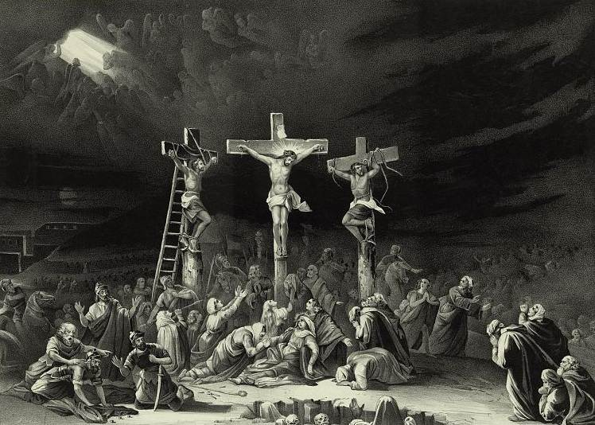
Holy Week Day 6- Saturday in the tomb.
Jesus' body lay in the tomb where it was guarded by Roman soldiers throughout the day on Saturday, which was the Sabbath. When the Sabbath ended at 6 p.m., Christ's body was ceremonially treated for burial with spices purchased by Nicodemus:

"He brought about seventy-five pounds of perfumed ointment made from myrrh and aloes. Following Jewish burial custom, they wrapped Jesus' body with the spices in long sheets of linen cloth." (John 19: 39-40, NLT)
Nicodemus, like Joseph of Arimathea, was a member of the Sanhedrin, the court which had condemned Jesus Christ to death. For a time, both men had lived as secret followers of Jesus, afraid to make a public profession of faith because of their prominent positions in the Jewish community.

Similarly, both were deeply affected by Christ's death. They boldly came out of hiding, risking their reputations and their lives because they now realized Jesus was, indeed, the long-awaited Messiah. Together they cared for Jesus' body and prepared it for burial.

While his physical body lay in the tomb, Jesus Christ paid the penalty for sin by offering the perfect, spotless sacrifice. He conquered death, both spiritually and physically, securing our eternal salvation:

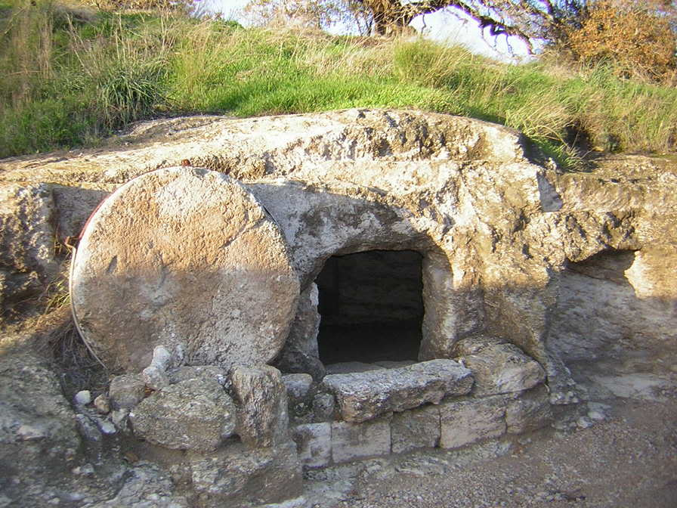
"For you know that God paid a ransom to save you from the empty life you inherited from your ancestors. And the ransom he paid was not mere gold or silver. He paid for you with the precious lifeblood of Christ, the sinless, spotless Lamb of God." (1 Peter 1:18-19, NLT)
Holy Week Day 7- Sunday, Resurrection Day!
On Resurrection Sunday we reach the culmination of Passion Week. The resurrection of Jesus Christ is the most important event, the crux, you might say, of the Christian faith. The very foundation of all Christian doctrine hinges on the truth of this account.

Early Sunday morning several women (Mary Magdalene, Mary the mother of James, Joanna, and Salome are all mentioned in the Gospel accounts) went to the tomb and discovered that the large stone covering the tomb's entrance had been rolled away. An angel announced, "Don't be afraid! I know you are looking for Jesus, who was crucified. He isn't here! He is risen from the dead, just as he said would happen." (Matthew 28:5-6, NLT)

On the day of his resurrection, Jesus Christ made at least five appearances. Mark's Gospel says the first person to see him was Mary Magdalene. Jesus also appeared to Peter, to the two disciples on the road to Emmaus, and later that day to all of the disciples except Thomas, while they were gathered in a house for prayer.

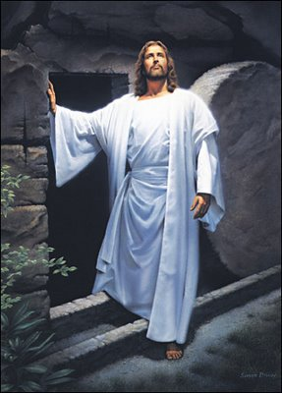
The eyewitness accounts in the Gospels provide undeniable evidence that the resurrection of Jesus Christ happened. 2,000 years after his death, followers of Christ still flock to see the empty tomb, one of the strongest proofs that Jesus Christ actually did rise from the dead.

LEAVING CERT.
RELIGION

MR. FLANAGAN

HOLY WEEK TIMELINE

THE TRIAL, CRUCIFICION, DEATH AND RESURRECTION OF JESUS CHRIST.

